* 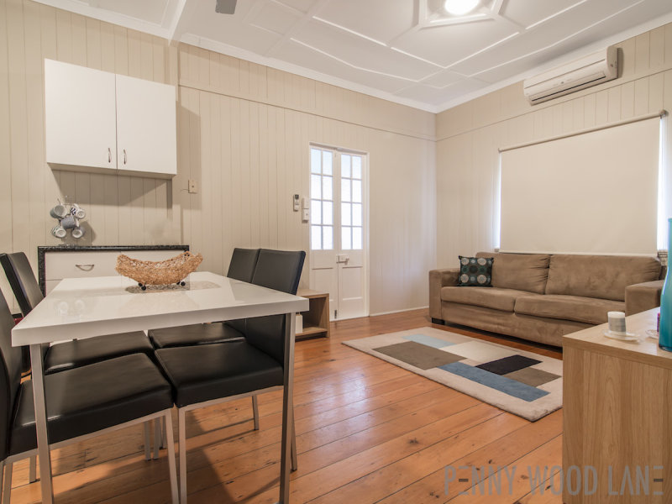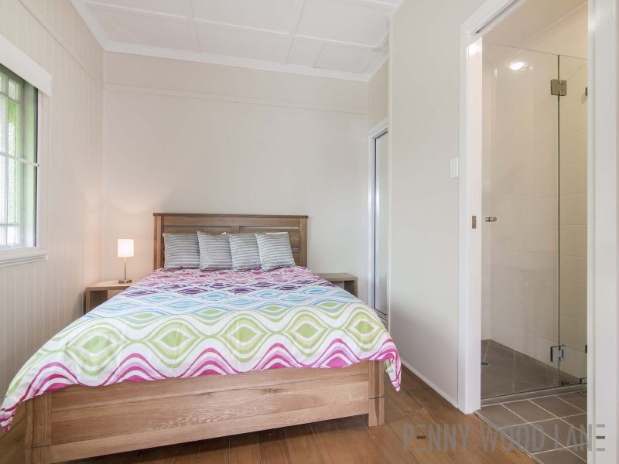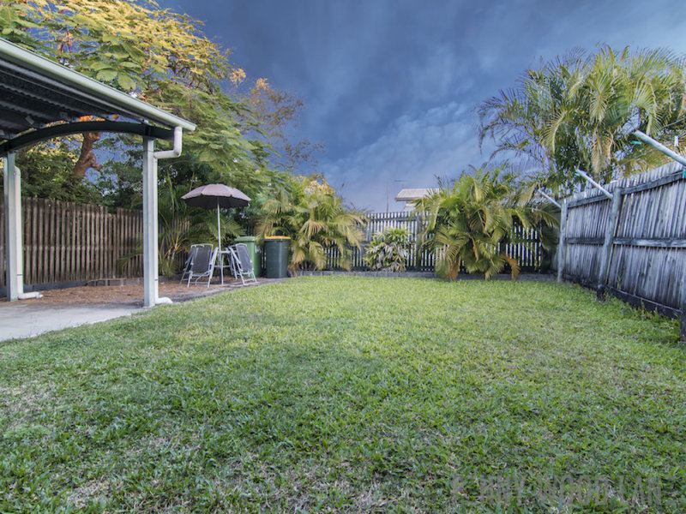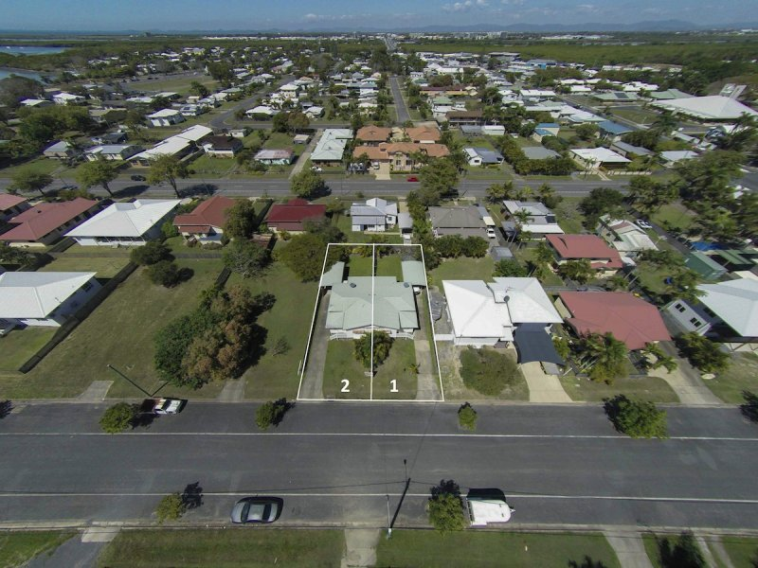$380 per week

 2 Bedrooms with QUEEN beds, built-ins, A/C & ceiling fans  
\* Ensuite to main bedroom  
\* Fully fenced (6 foot timber) yard with lockable gates  
\* Secure, undercover parking in backyard  
\* Lawn locker shed with mower and whipper snipper  
\* Sunroom with built-in study  
\* Character Cottage - polished timber floors throughout  
\* Completely air conditioned in EVERY ROOM  
\* Fully furnished with linen and kitchenware  
\* Only minutes' drive to shops and services  
\* Pets approved upon application - Great yard for dogs!!